Tri-Fit Challenge: Flexibility/Core
- In and Out – This is an ab exercise completed by tucking in your arms simultaneously with your legs. A modification with beginners can be using your hands to balance you as you tuck your legs in and out leaving your legs slightly above ground the whole time. Complete 30 reps or as many as possible in one minute
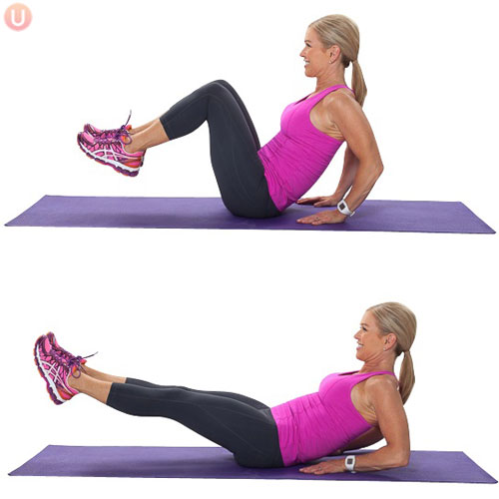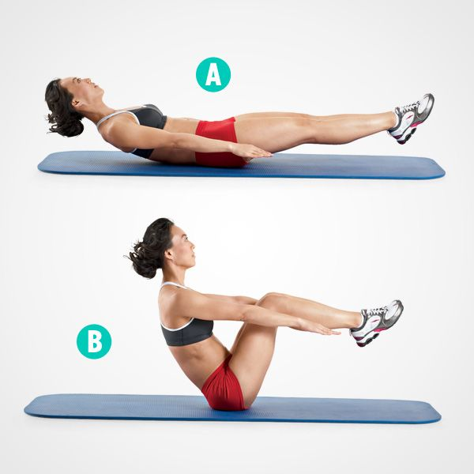
- Side to Side crunches – This exercise is completed by laying with knees bent and feet flat on the floor, moving side to side (like a turtle) on the ground working your oblique muscles. Complete 30 reps or as many as possible in one minute, both sides is considered one rep.
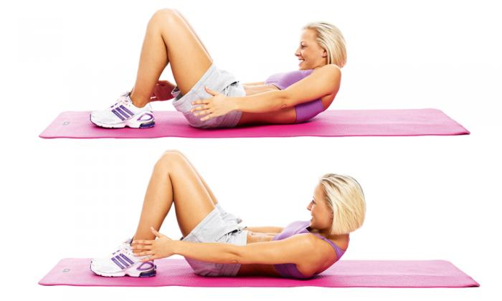
- Bicycle Abs – This exercise consists of alternating elbows to knees while the legs/feet are slightly above ground at all times. A modification for this exercise to make it easier is to not include the use of alternating elbows to the knees and just alternating the knees toward the stomach, such as riding a bicycle. Complete 30 reps or as many as possible within one minute, with one on each side being one rep.
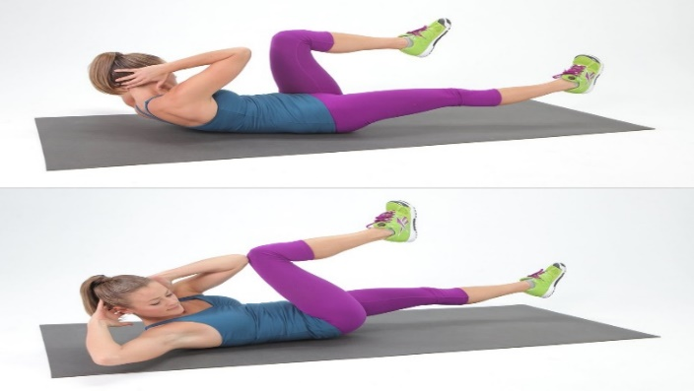

- Warrior Stretch – Each stretch will be completed for a total of one minute. The Warrior pose has arms straight out from one another with a straight back leg, lunging forward and holding this pose for 3 sets of 20 seconds with a 5 second rest.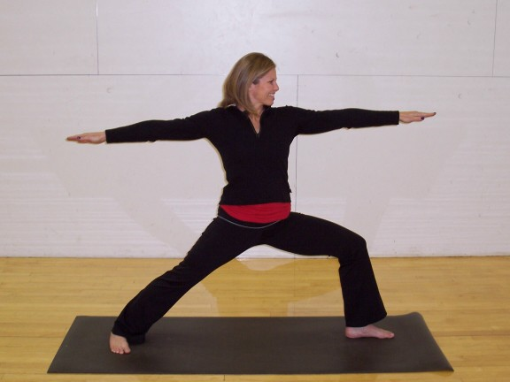
- Child’s Pose - Each stretch will be completed for a total of one minute, arms are stretched out and the participant leans all the way back into a deep stretch with head facing the floor and sitting back. 3 sets of 20 seconds with a 5 second rest.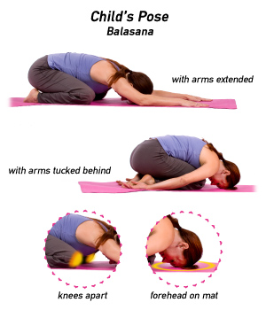
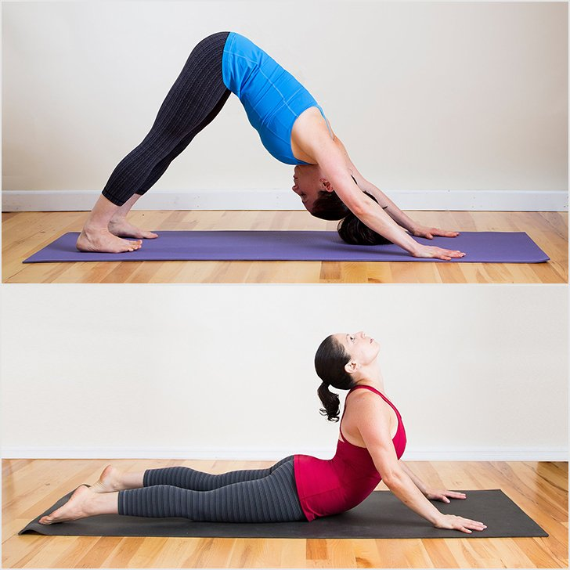
- Downward Dog – Each stretch will be completed for a total of one minute. This stretch is completed by legs lying against the floor and rounding the back toward the ceiling for 10 seconds, then change position to palms on the floor moving to a flat back position with straight legs if possible and hold for another 10 seconds. 3 sets of 20 seconds with a 5 second rest.

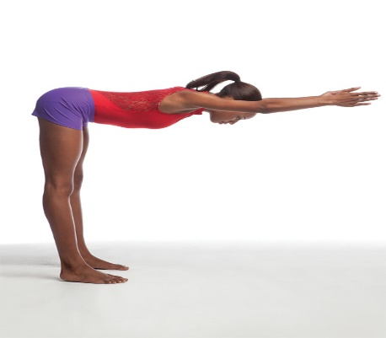
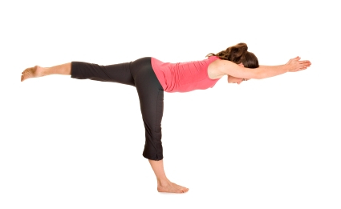
- Flat Back – Flat back stretch is moving with your arms outstretched in front of you, leaning forward until your back is flat and parallel with your arms. An extra challenge could be lifting your leg up and maintaining your balance. 3 sets of 20seconds with a 5 second rest.

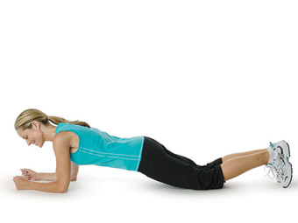
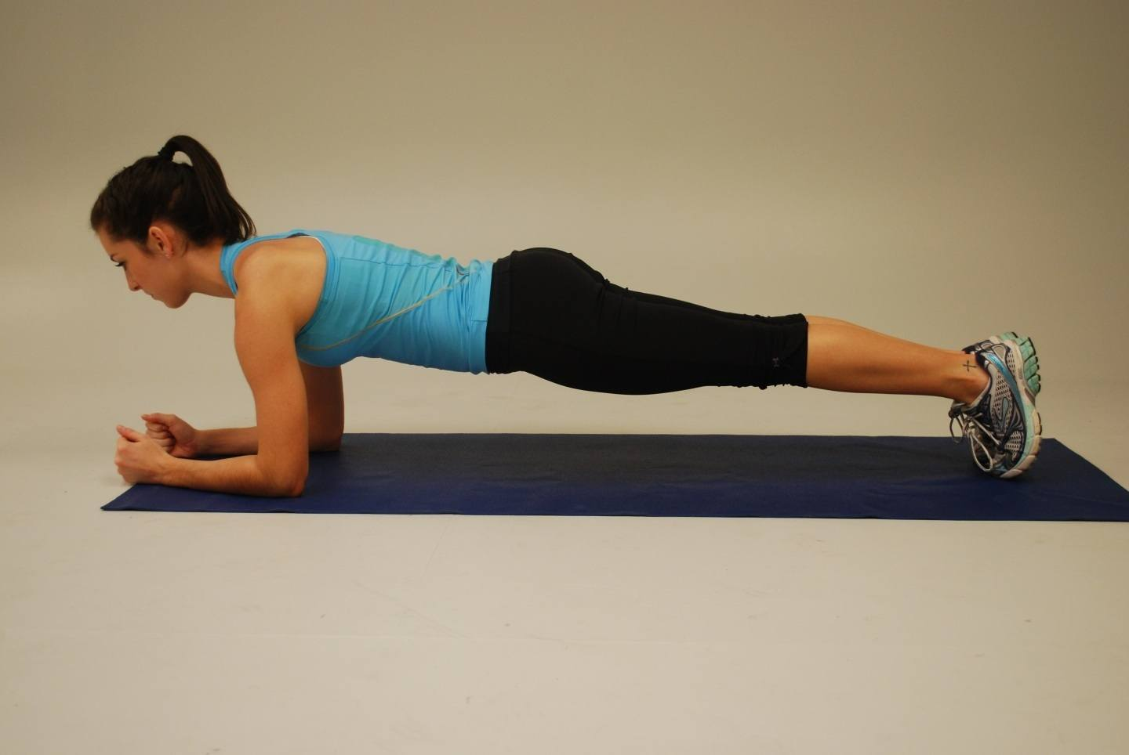
- Ab Plank – With elbows on the floor, maintaining a flat back, the core is lifted up and hold this position for 2 sets of 30 seconds. A modification if too difficult, is hands on the floor instead of elbows and leaving knees on the floor for extra support. 2 sets of 30
seconds with a 15 second rest.

*All the exercises listed above will be performed twice*

The benefits to Core Exercise and Flexibility are:
- Increases range of motion around the joints and prevents muscle tightness
- Assists in preventing lower back pain
- Increase muscle strength, stability, and balance
- Help with general well being and improve quality of life

